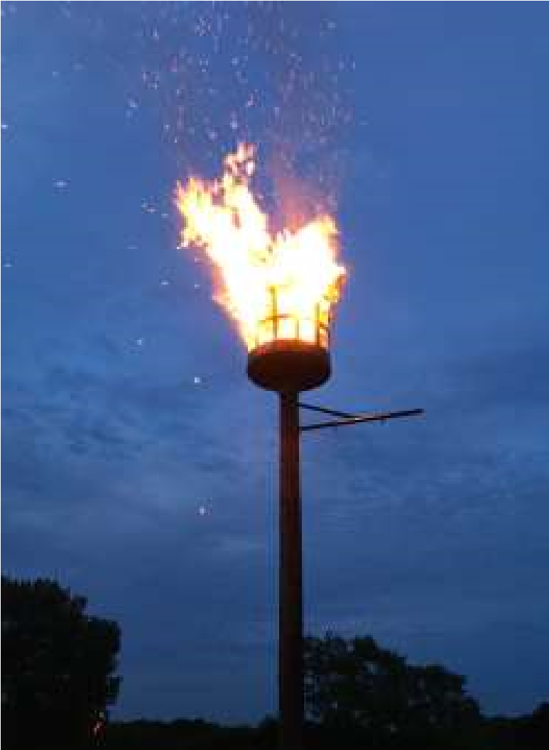

The Newsletter for Middleton on the Wolds

Issue No 39

JULY 2022

NEXT COPY DATE

14th JULY
What a wonderful Jubilee weekend it was for our village. Even the cold wind and rain didn’t dampen the spirits for the street parties which adjourned to warmer places, The Paddocks even moved theirs to the Village Hall. A few photos are scattered around the newsletter taken by me, Nick Jones and Ann Swallow.
Please send in your contributions by the end of the copy date. If I don’t acknowledge them please get in touch to make sure they have arrived.
Thank you
Lyn
4 The Paddocks 219500 middletonflyer@yahoo.com
ADVERTISING COSTS for the Messenger

Rates Month Year Whole Page £25 £150 1/2 Page £15 £100
1/3 Page £10 £60

Full colour - Print run 500 copies
Contact: Tina 01377 217242, middletonflyer@yahoo.com

Editorial
Well, I thought the jubilee celebrations were an absolute triumph. The gala had been superbly organised and this showed in how it turned out on the day.
The floral displays in the Church were beautiful and the beacon blazed! And they were just the events I went to see. There were also the several events run by the Countrywomen's Association, those in the Village Hall and, of course, the street parties. A lot of work went into all this and we should all give a big thank you to everyone (and there weren’t really that many!) who put in so much effort and gave up so much of their time to make it happen. Who knows, maybe some of these celebrations could become annual events.

The other great happening was, of course, the Great Oil Spill Disaster of 2022 left a slick on the pond that made the Torrey Canyon (ask your dad - or maybe grandad) look like a greasy breakfast! Seriously, though, the fumes were terrible and quite a few ducks were covered in oil and were in a bad way. But there was a rapid and effective response from residents who helped organise a similarly rapid response from the RSPCA, East Yorkshire Council and from the volunteers of the Bradbury Bird & Wildlife Rescue.

Two issues that were resolved by villagers working together to make things happen. Maybe we should use them as a model for the future?

Stay safe.
Mike

If you have any ideas, comments or complaints (especially complaints) you want to share then send an email to middletonflyer@yahoo.com.

QUIZ PAGE
- What is the capital of Portugal?
- What does ESP mean?
- What is a Silky haired goat called?
- What was the group that opposed the Jedi?
- What fish can swim backwards?
- Who was the author of 'A Brave New World'?
- In what decade were flavoured crisps first introduced?
- Who sang about Mrs Robinson?
- Where will you find the Mary Rose?
- Where is the National Motor Museum?
Quiz set by Rowland Wooldridge
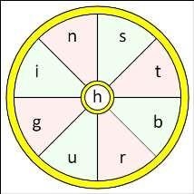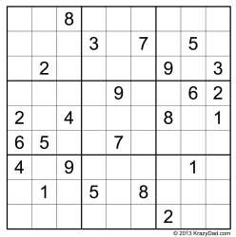
All answers on
page 19

SEASONAL WORD WHEEL

Try to find the timely word or words
and then create as many words possible
with the letters in the word wheel. You
can only use each letter once and every
word must include the letter in the
centre of the wheel.

SUDOKU

St Andrew’S church

Services for July
Sunday 3rd | 10.30am | Morning Prayers. RL
Sunday 10th | 10.30am | Holy Communion. Rev’d Jane Anderson
Sunday 17th | 10.30am | Holy communion.
 |  | Rev’d Canon Kate Goulder
Sunday 24th | 10.30am | Holy Communion. Rev’d Anne White
Sunday 24th | 10.00am | Benefice Holy Communion. Venue to be
 |  | announced

The wolds METHODIST CHURCH

Services for July
 | Sunday 3rd 10.30am | Service at the Wolds Methodist Church.
 |  | Deacon Keith Gough
 | Sunday 10th 10.30am | Service at the Wolds Methodist Church with
 |  | Baptism. Rev Dr Richard Teal
 | Sunday 17th 9.00am | Café style worship at the Wolds Methodist Church.
 |  | Pastor John Gleaves
 | Sunday 24th 10.30am | Service at the Wolds Methodist Church.
 |  | Mrs Irene McGowan
 | Sunday 21st 10.30am | Service at the Wolds Methodist Church.
 |  | Mr John Stephenson
COFFEE MORNING
at The Wolds Methodist Church Bainton
Wednesday 13th July 10.00am to 11.30am
All Welcome
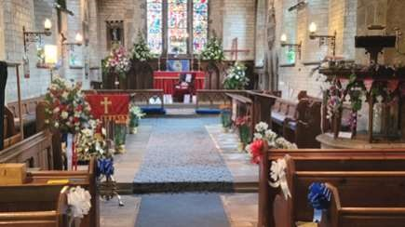

A Jubilee Thank you

On behalf of the St Andrews Church PCC I should like to offer a massive
thank you to Rev Jane Anderson who masterminded the
“
Festival of
Flowers
”
project and to all the ladies who created the gorgeous and
colourful flower arrangements and dazzling displays together with the
input of our Primary School.

All these contributions enhanced our beautiful church perfectly for the
Platinum Jubilee Festival.

I also thank those who sponsored the displays, the volunteers who manned
the church during this time and the people who made a supreme effort to
call in to view the efforts.

The service on Sunday morning was very well attended
–

a fitting
conclusion to a very fulfilling and successful Jubilee weekend. We are
very grateful to all of you who supported us so generously.

Betty

a note from your vicar
July is a beautiful time of year in the life of the garden and, hopefully, this year we will have enough sunshine to enable us to sit and enjoy them.
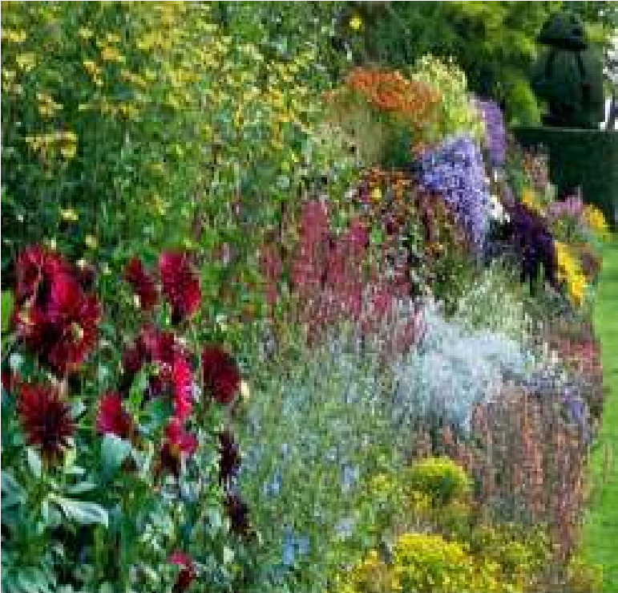
In a new book, ‘Britain’s Wild Flowers’ published by the National Trust, Rosamond Richardson shares the traditions, superstitions, remedies and literature associated with our native flora.
Forget-me-nots grow under the trees in our garden and over the last 3 years they have increased in number. I like how the bright blue flowers seem to glow in certain light. There are many legends surrounding this diminutive little plant’s name. Here are a couple of my favourites:
While walking through the Garden of Eden after the Creation God
noticed a small blue flower and asked its name. The flower, overcome with shyness, said, ‘I’m afraid I have forgotten, Lord.’ And God answered, ‘Forget me not, and I will not forget thee.’
Another story tells that the infant Jesus was sitting on Mary’s knee as she looked lovingly at him and he wished there were some way to make everyone able to see the blue of her eyes.
They are a symbol of fidelity, true love and constancy. It was also thought that if you planted them on the grave of a loved one the flowers would not die as long as you lived.
Blacksmiths would hang a bunch in their Smithy to protect horses from injury. Tufted Forget-me-nots were also made into a syrup to treat lung complaints.
Clouds of them sprang up on the battlefields of Waterloo in 1815 and they came to symbolise remembrance of the dead. In France these flowers are worn in the same way we wear red poppies.
I hope you have a good summer, and plenty of time to enjoy the beauty all around us.
Jane
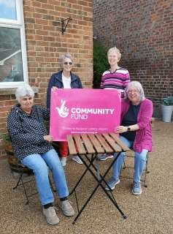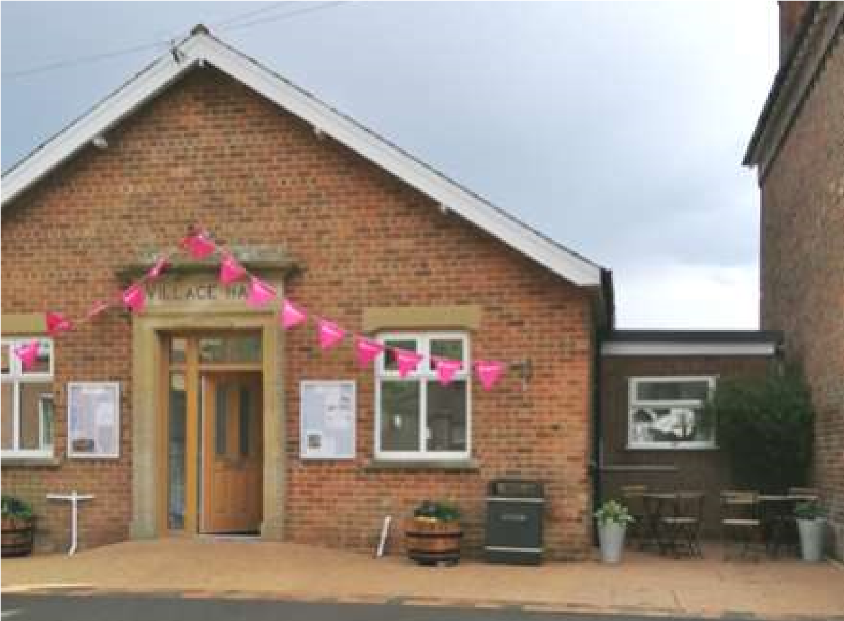
The Village Hall committee are
very grateful for the funding that
we
have
received
from
the
Community Fund to complete the
renovations of the hall by being
able to improve the look and
accessibility of the frontage with a
resin surface sloping up to the front
door, patio tables and new planting
in the tubs.

The hall has been well used over
the Jubilee Weekend with events
held inside on each of the 4 days
-

see photos on other pages of this
Messenger.

Village hall

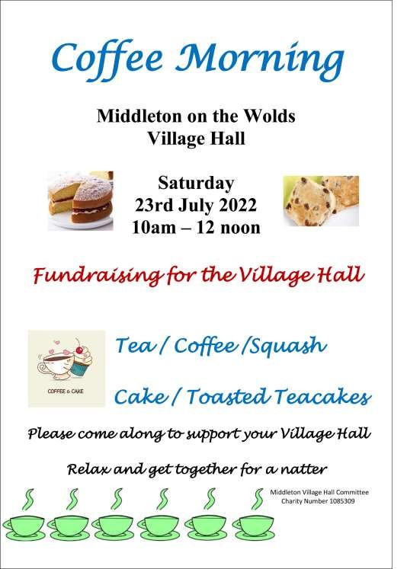

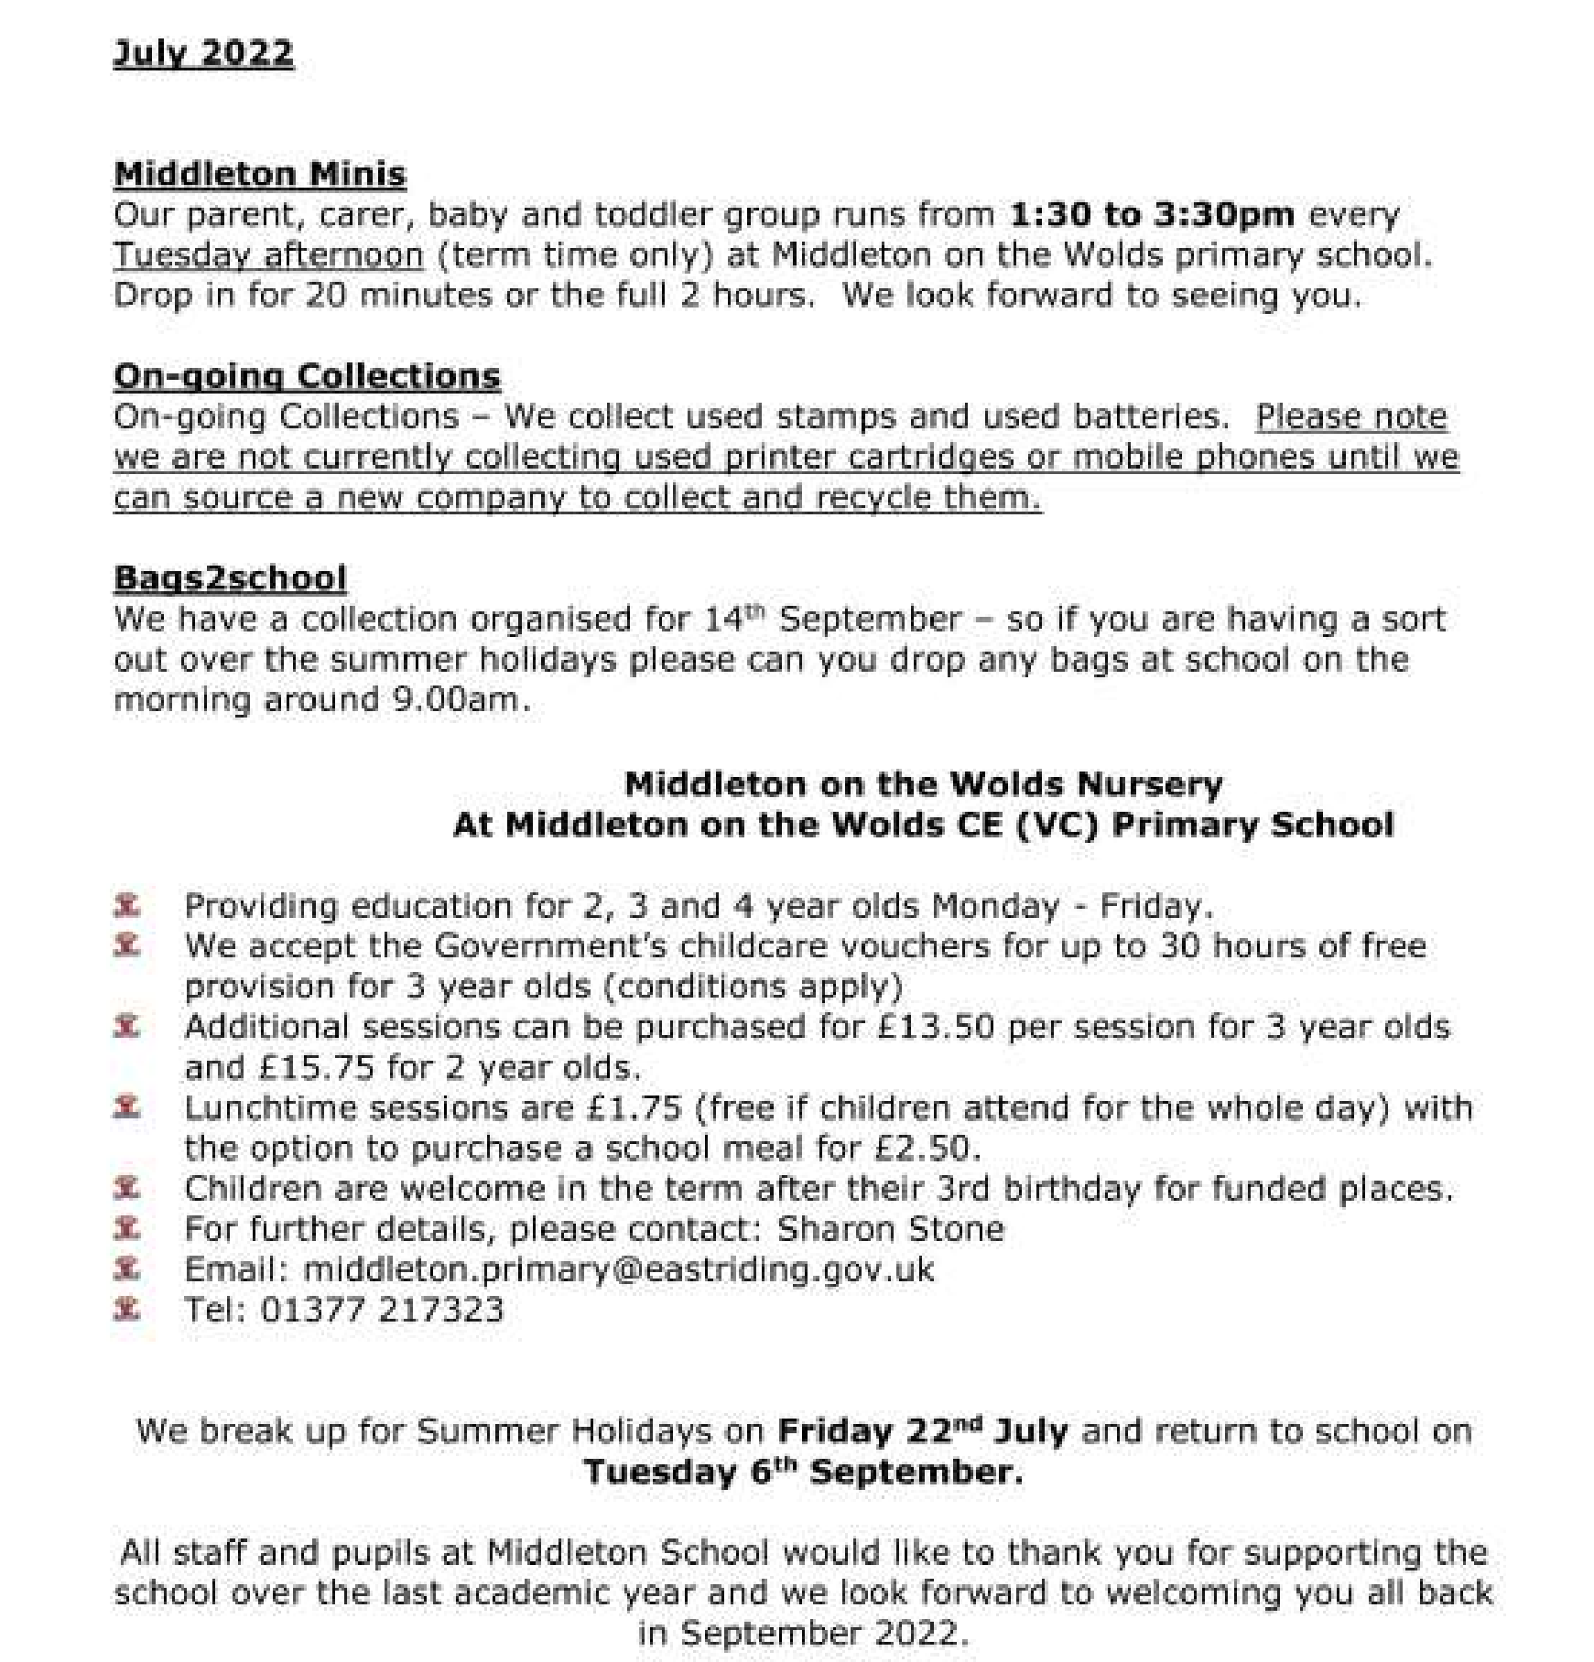
Middleton on the wolds ce ve school
Executive Headteacher: Mrs E Harros

Station Road, Middleton on the Wolds, Driffield YO25 9UQ

E
-
mail:middleton.primary@eastriding.gov.uk Tel: 01377 217323

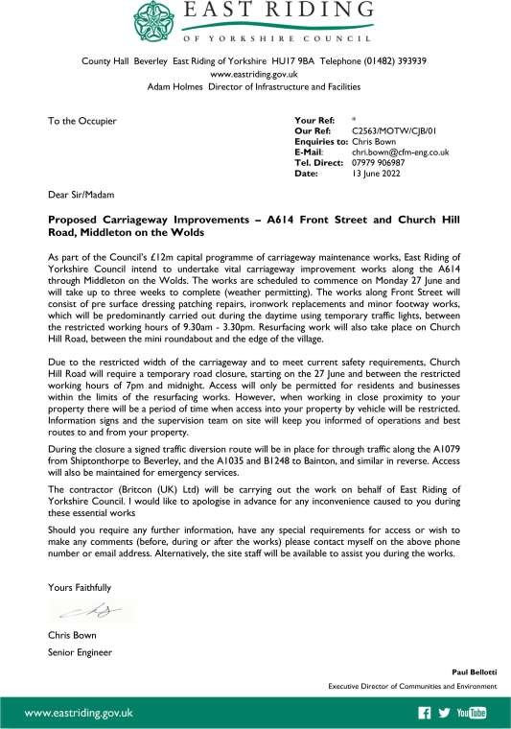

parish council news
MIDDLETON BEACON LIGHTS UP THE
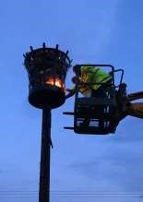
JUBILEE SKY
The newly installed Beacon was at the centre of the Queens Platinum Jubilee celebrations. Over 100 residents visited the field on the evening of 2nd June and witnessed the inaugural lighting. It was lit by Parish Councillor Tina Walker who braved a raised tractor platform provided by local young farmer Ben to ignite the wood which was kindly provided by Soanes Poultry. Vince gave a salutation and a toast to the Queen whilst Nick and Peter acted as fire stewards and first aid back up. A good time was had by all and in years to come the beacon will become a landmark for our village. Nick Jones
CALLING ALL BUDDING DESIGNERS!

We need your help! Are you creative and have a sense of tradition about our village?
We are looking for an innovative design for a village shield which, when created, will sit under our newly installed Beacon. Only stipulation is it contains our village name with perhaps a logo relevant to the village. Apart from that the worlds your oyster so why not get creative and have a go. Please send your entry in via either email to nj@mothwparishcouncil.com or drop a hard copy into the Reading Rooms mail box.
There will be a prize for the chosen entry.
Good luck!
Nick Jones All entries to be in by 31st July

New Parish Councillors
We still have vacancies for 3 Parish Councillors. To be a councillor you must be at least 18 years old and either be registered to vote in Middleton or have lived, worked or owned property here for at least 12 months.
The council is definitely not made up of one ‘sort’ of person; the only thing we have in common is that we want to make Middleton a better place for everyone. If you would like to help us do this, please contact the Parish Clerk, Sandra Morrison, pc@mothwparishcouncil.com, or speak to any councillor.

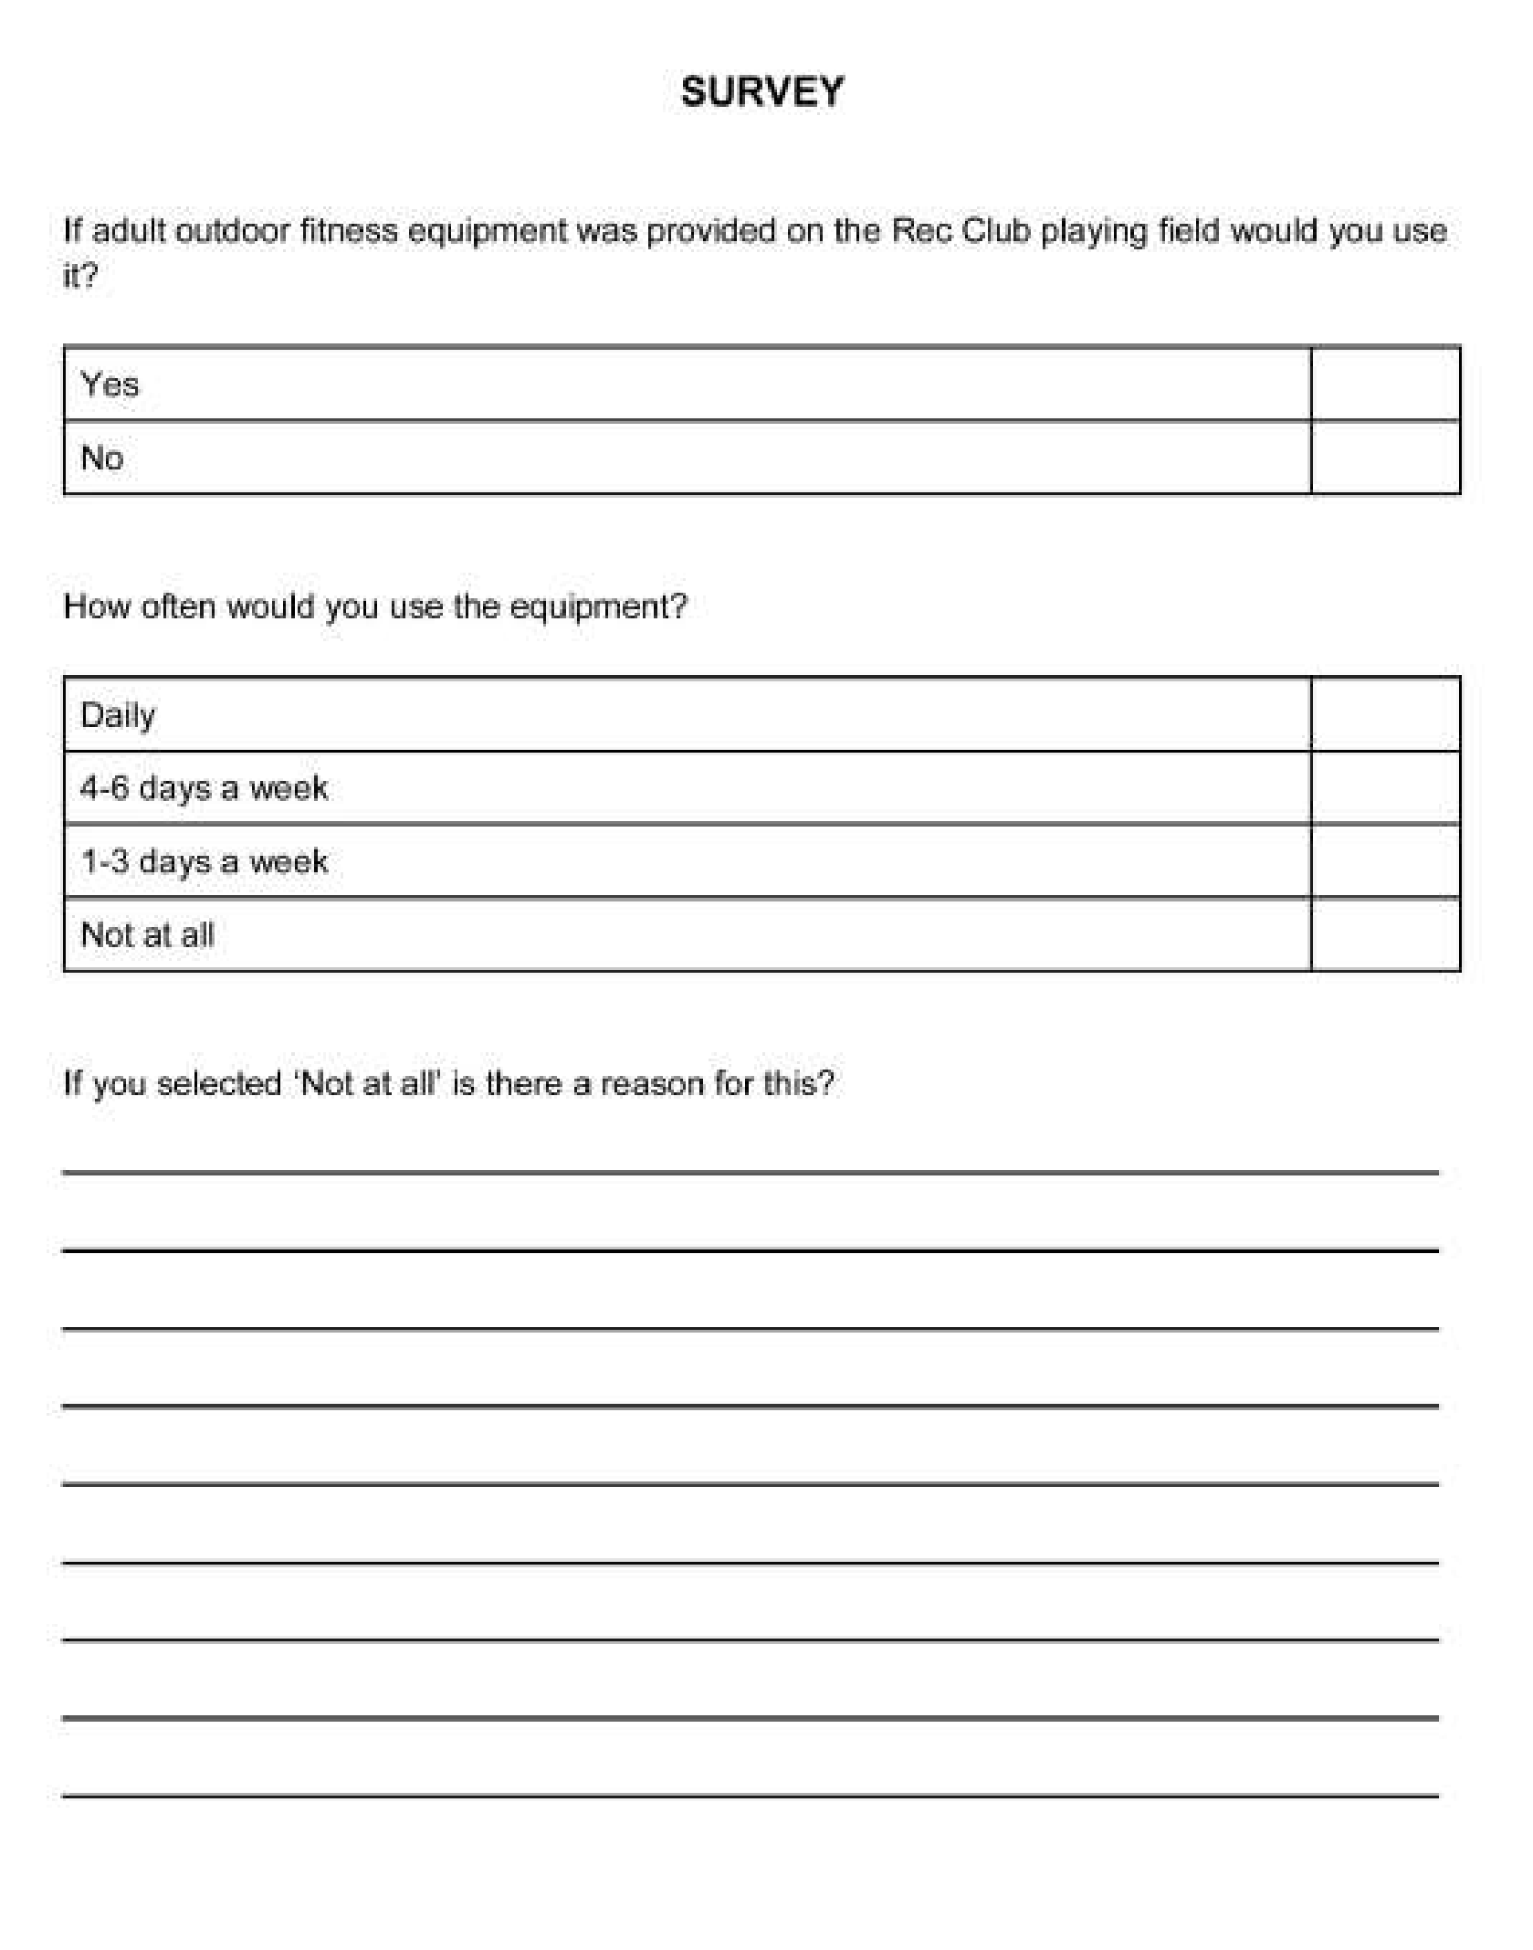

LOCAL HISTORY
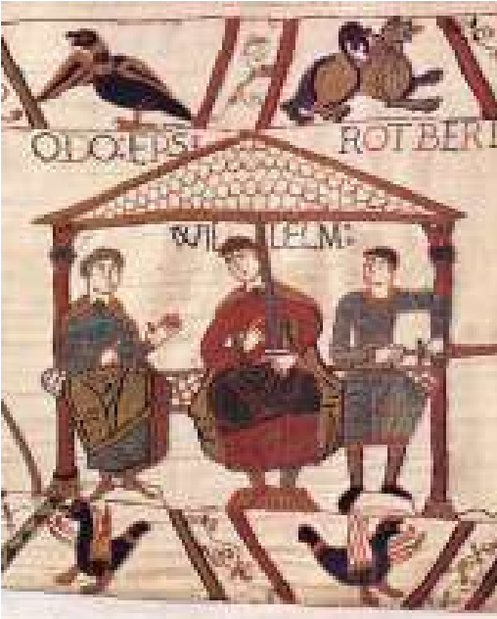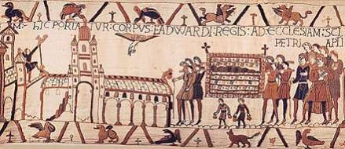
1066
AND AFTER

If any proof were required for the existence of
Middleton
-
on
-
the Wolds one could not do better
than read the entry in the Domesday Book. This
unique document was speedily compiled in 1087
as a stocktaking excercise to further assist king
William by establishing his assets and enabling
him to strengthen the strict rule he had imposed
after the victory over king Harold Godwinson at
the battle of Hastings in 1066. The entry for the
village, though tricky to read, reveals that there
was a church and priest and Archbishop Ealdraed,
the man who crowned William king on Christmas
day 1066 was a landowner. A later entry showed
Robert de Mortain (right)

that Robert, Count of Mortain in Normandy, the half brother of the new king, who had helped him in the battle and who had been awarded land all over the country in recognition of this service was also given land in Middleton which he later lost. A book published in 1915 entirled “Early Yorkshire Charters” acknowledges that “ the feudal distribution of Middleton on the Wolds was somewhat complicated and the particulars of the various tenures at the Conquest and in the Survey are incomplete and contradictory”

There was sporadic opposition to William’s takeover culminating in the “Harrying of the North” a brutal excercise in mass destruction bordering on genocide and the laying waste of vast tracts of land and buildings as a punishment for the rebellions. Historians disagree on the severity of this, citing the fact that the king did not have the military strength to carry out the task on such a large scale. There is also a belief which cannot be proved that certain places in East Yorkshire were spared because of a “miraculous” incident of a religious nature in Beverley which persuaded the king to allow lands associated with the monks of Beverley to remain unmolested.

After the conquest the pattern of land ownership changed and the feudal system which had existed in the Anglo Saxon/Viking times was strengthened. This meant that the king himself owned all of the land from which he was able to grant estates to his supporters in return for military service. These estates were then administered as a series of manors each having a definite hierarchy descending from the Lord of the Manor down through the villeins or tenants to the serfs. It hardly needs to be said that the recipients of land were in most cases individuals of Norman descent who spoke French and continued to do so until the end of the 1300s. Society in the middle ages identified three “estates” believed to be ordained by God: those who fought; those who prayed; and those who worked: each estate was complicated by many subdivisions.

The life of the lowest members of society was not good: Aelfric, a tenth century monk, gave a description of a ploughman’s lot:

“I work very hard. I go out at dawn and I drive the oxen in the field and yoke them to the plough. However stark the winter is, I dare not stay at home, for fear of my lord. I have to yoke the oxen and fasten the share and coulter to the plough, and every day I have to plough a full acre or more. I have a boy who drives the oxen with a goad and even now he is hoarse from cold and shouting. I fill ox-bins with hay and water and I clear out the dung.”

In the years after the conquest life in small settlements was no doubt one long daily grind, varying slightly with the seasons and relieved from time to time with the festivities of the pre-reformation church; a passion for cruel sports and robust humour. One year must have been very much like another and the average lifespan of the medieval peasant would have been short; the later phrase “Survival of the Fittest” being particularly apt. Health and safety was a veritable minefield with all sorts of hazards awaiting the unwary. The state of medical knowledge has been summed up by a modern historian Ian Mortimer as “A bizarre mixture of arcane ritual, cult religion, domestic invention and a freakshow.” In Middleton, apart from the building of the church and the occasional cryptic reference to individuals nothing much is known about the village itself or the lost village of Kiplingcotes which was situated west of the present Kipling House farm.

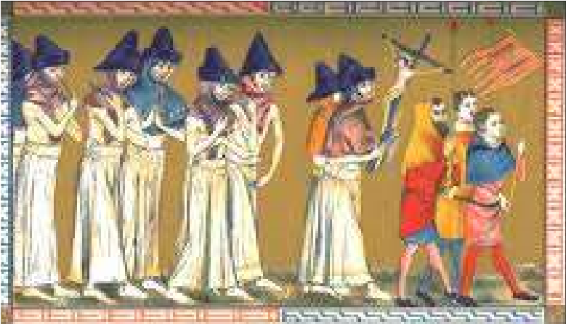
The years from 1315-22 saw harvest failures brought about by the worsening climate. The canon of Bridlington spoke of misery “such as our age has never seen!” It was in this period that the church at Bainton had to be rebuilt after the destruction wrought by the Scots who were
harassing Yorkshire after the battle of Bannockburn. The Black Death, a disease thought to be spread by the bite of fleas carried by the black rat appeared in 1348 and 1361. It caused havoc throughout Europe and in England the high number of deaths meant a drastic reduction in the workforce resulting in higher wages of labourers which the government could not control and which in turn hastened the decline of feudalism.. However M W Beresford in his book “The Lost Villages of Yorkshire” states “in only a very small minority of cases did the Black Death empty the villages of the East Riding.” Despite this there is reference to the fact of 60acres of land in Middleton being waste and untilled due to the great mortality and it is believed that the population of Beverley was halved.

It was in this period that The Peasants’ Revolt broke out, mainly in the southern counties, against the imposition of the third poll tax which inspired one of the leaders, Wat Tyler to make extravagant demands for political and social change. The rebellion was crushed.

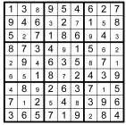
Geoff Wisher

BRIGHTSUN

QUIZ ANSWERS

1

Lisbon

2

Extra Sensory Perception

3

Angora

4

Sith

5

EEL

6

Aldous Huxley

7

The 1950's

8

Simon and Garfunkel

9

Portsmouth

10

Beaulieu Hampshire

Local Birds & wildlife
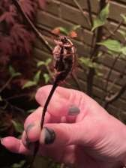
The long weekend is over, and everyone is back at school and work, so here’s something exciting to cheer you all up! (Drum roll …. ) Just after the last deadline I got an email from Becky, with incredible news about regularly seeing a cockchafer in her ^{Swift} garden! I was amazed, I always thought this was a beetle that only appeared in the south of the country so that is something to look out for in the evenings! (Well, I was extremely excited – you can probably tell – so I hope others are too.
Presumably that means spring is spreading up here quickly, and we have had a few early thrills!
It’s been great seeing plenty of swifts around this year. Normally they seem to arrive after the house martins and swallows, but this year they were the first to announce their arrival with their wonderful screaming calls. Since then I have seen some house martins, but so far very few possible swallows which I might have overexcitedly imagined as I was so keen to see them back.
I was watching a group of about 6 swifts hunting insects over the embankment behind our garden, when suddenly there was a flurry of activity as they turned on a passing sparrowhawk and by outnumbering it drove it off. I can’t imagine a sparrowhawk taking a swift on the wing, but they obviously saw it as a threat.
We’ve continued to see brimstone butterflies, but not too many other species of butterfly: I’ve only seen a couple of red admirals, and very few tortoiseshells and the odd small white (I looked them up!)
It’s getting a bit later in the year now, but “Dawn Chorus Day” turned up earlier in spring. I went out at just before dawn, and it
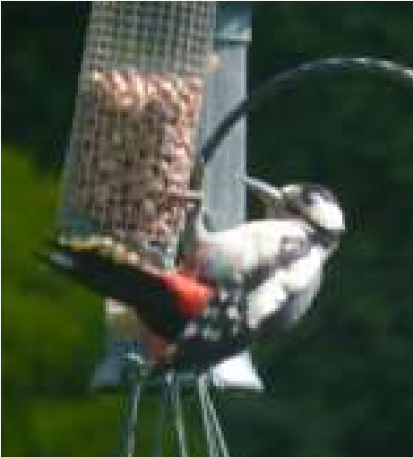
was a magical experience. The dawn chorus has slightly abated now, as birds are sitting on nests, but the males are still proclaiming their territories so it’s still well worth going out into your garden in the grey early morning, just before sunrise, and having a listen – and of course if you have a smartphone you can load ‘Merlin’ the app I mentioned last month (and no, they don’t pay me, and I have established that you don’t have to pay them!) and identify all the different calls.
Linda got in touch to tell me that for the first time she had seen a greater spotted woodpecker in her garden on her feeders – really interesting as they usually seem to be birds that prefer woodland or at least a quite a few trees around. I only get them in my garden occasionally, and I still have the remnants of the ash trees on the embankment behind our garden, while I think Linda has much more open land around her.
So …. Any unusual sightings? Any interesting behaviours? Please let me know! NB Anything I received between 9th and 14th June will have to go in the next Messenger, so don’t be discouraged if I haven’t included it here.
Barbara
Lavenderbarbara97@gmail.com or 0777 192 7868
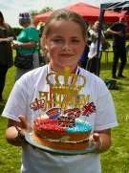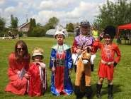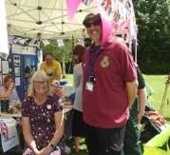
Prize winners at
the Gala

The Community
Tent

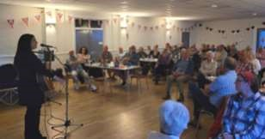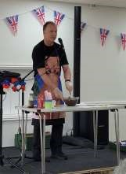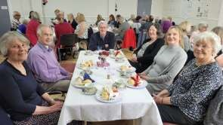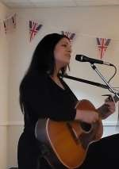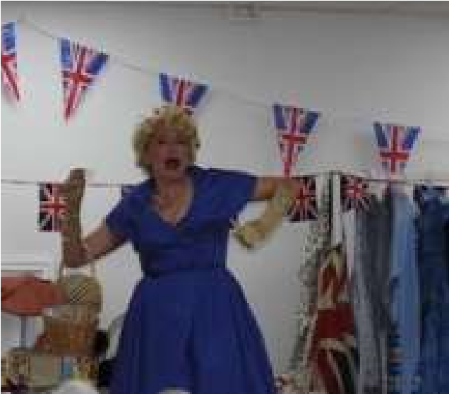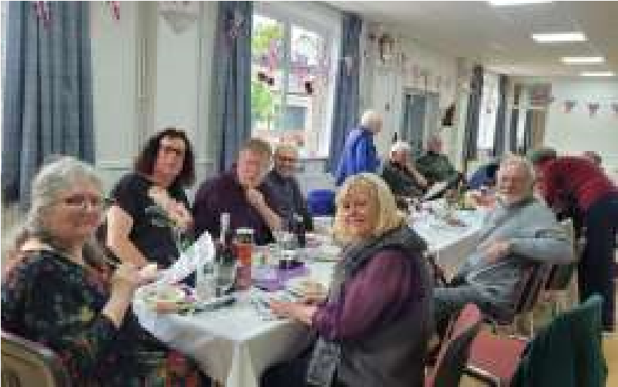

jubilee pictures

Edwina Hayes Concert

Afternoon Tea with
Andy Lloyd

The History Wardrobe

The Paddocks Street Party

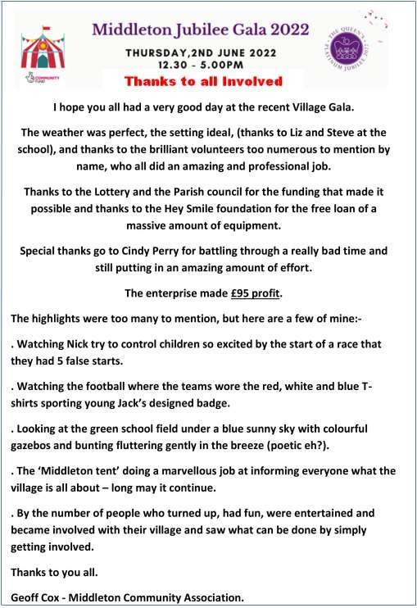
Advertising Feature

Advertisements
Advertisement

Advertising Feature

Regular group activities
Weekly Groups
Monday Pilates | 5.00-6.00pm Village Hall
Tuesday Tai Chi | 2.30-4.00pm Village Hall
Wednesday Line Dancing | 7.30-9.00pm Village Hall
Thursday Middleton Movers  July | 2.00-3.30pm Village Hall
3 Womblers Litter Picking | 10.00am Lime View
4 Parish Council | 7.00pm Reading Rooms
6 Village Hall Committee | 2.00pm Village Hall
12 Book Group | 10.30am St Andrew’s Close

LOCAL CONTACTS Bell Ringing Chris Atkin |  | 217285
Book Group/Middleton Movers | Lyn Dennis | 219500
Bowls Club | Rob Bradley | 217435
Country Women’s Association | Christine Johnson | 217374
First Responders | Chris Brent | 219469
Line Dancing | Pat Pottage | 217516
Methodist Chapel | Jane Gray | 07870 562455
Middleton Messenger | Mike Kelly | 07713 620912
 | Lyn Dennis | 219500
 | Tina Walker | 217242
Middleton Green Group | Liz Naylor | 219072
Middleton Womblers | Andrew Naylor | 219072
Parish Clerk | Sandra Morrison | 01262 470496
Pilates | Ian Stephenson | 07973 755717
Reading Rooms | Kath Bentley | 217456
Recreation Club | Dave Newlove | 07901 833784
St Andrew’s Church | Rev Jane Anderson | 219471
St Andrew’s Church Wardens | Chris Brent | 07766 162743
 | Lesley Kelly | O7907 451046
Table Tennis | Louise Newlove | 217801
Village Hall | Lyn Dennis | 219500
Village History Geoff Wisher |  | 217517
email: middletonflyer@yahoo.com page 28

